Jason Silvestri’s 2024 Resume (SLIM)

Solution Architect, Lead, Sr. Web /Mobile Software Engineer, & Full-Stack .NET Developer

v 2024.4.0.001

My latest contact information is as follows:
61 Forest St.
Executive Suite #2
Middleboro, MA 02346

Cell: (508) 851-9445
Office: (508) 851-9445
Email: therealjasonsilvestri@gmail.com
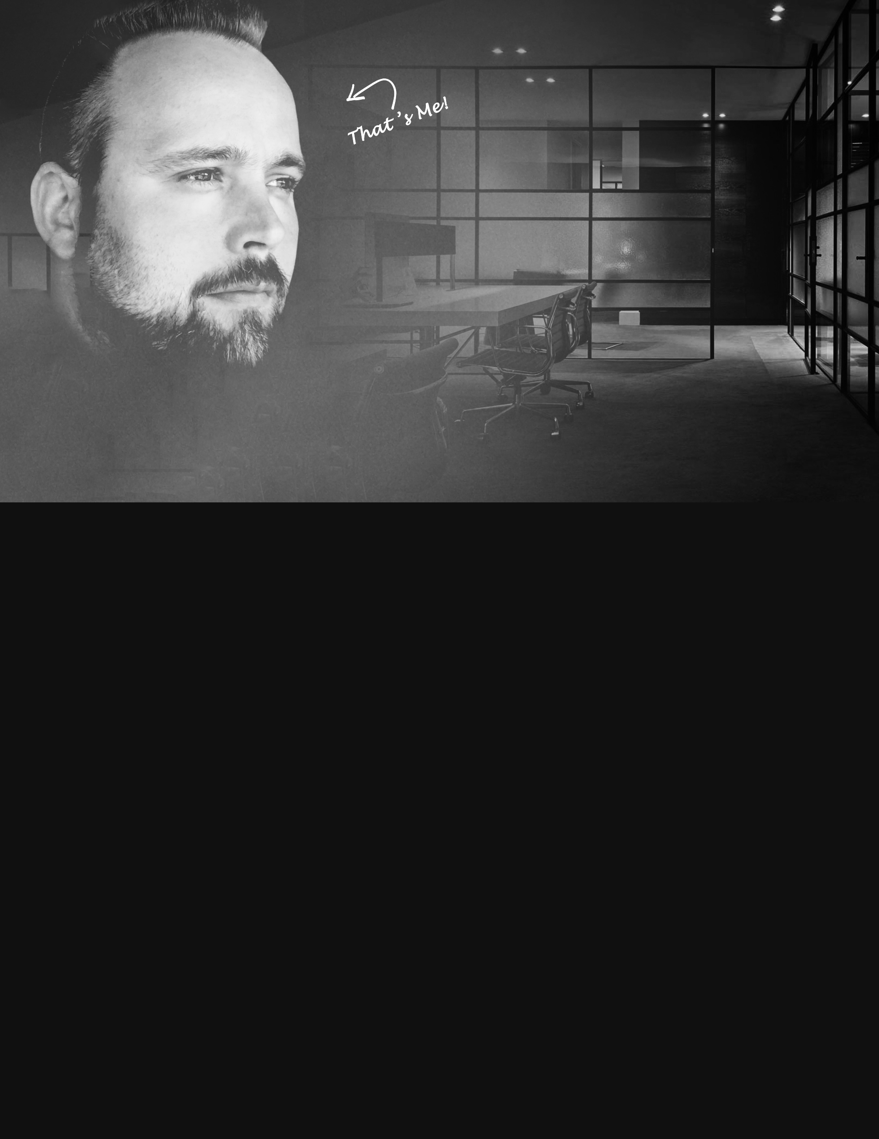
EXPERIENCE  Primary Objective  “As a successful & and well-known Solution Architect, Lead Sr., Web/Mobile Software Engineer, and Full-Stack .NET Developer, I help separate some of the World's most innovative Startups & Fortune 500s from their competition.™”  I’m truly honored to have worked alongside some of the most skilled developers I have ever known to exist, across all development tiers, on projects involving brands such as Deal Hopper™, DoorDash, Microsoft Azure, Red Curve Solutions, Optum, UHG, Trip Advisor, Union Bank®, Botox Cosmetic, STIHL®, Citizen Watch, American Family, the NFL, WWE, Rovio, Dassault Systèmes, MKS, MIT, Harvard Business & More!  I have more than 2 decades of experience, using over 40 different web technologies, IDEs, Design Patterns, Best Practices, and Graphic/Video Editing Designers. My primary technology full-stack focus today, includes HTML5, CSS, Asp.NET Core, Blazor Bootstrap, Blazor, .NET MAUI, Razor Pages, MVC, Ajax, Bootstrap, Entity Framework, SQL Server, jQuery, Ajax & JSON, developing multi-threaded applications, SaaS, Web Services, Web APIs, and multi-platform mobile & web application user experiences, specifically designed for most smart-phones, tablets, laptops, desktop computers & a range of smart TVs.  The company structure I look for is that of a relatively stable environment, with an engaging philosophy, smart & collaborative teams, and a friendly but firm culture (although not a requirement). I’m completely outfitted, capable, and competent to work in most environments, including “high-pressure situations”, whether it be On-Site, Remotely, or in a Hybrid setting, regardless of travel time, location, relocation, etc.  I am looking for a potential employer who will allow me the pleasure of working with them as a 1099 Contractor, W2 Contractor, or Direct Hire Employee. In the case of direct hiring, I would prefer a 3-, 6-, 9- or 12-month contractor-to-perm basis, first (when/if possible). The goal is to ensure both sides get to evaluate the collective relationship; to ensure the business requirements I was originally responsible for are still the focus, and if not, why, and of course, to ensure the team dynamic is what both sides envisioned when I started; ultimately, ensure everyone on our team is happy.  jSilvestri.com  Yes! I’m On-the-Market, available, and ready to start work immediately!  Soon after working right through the first half of the COVID-19 pandemic, I had plans to take time off while the World was doing the same. During this time, I ended up volunteering support and/or working on a few overlapping projects that are worth making note of before diving into the rest of my employment history.  JSILVESTRI.COM BETA V 2024 | Middleboro, MA | Solution Architect, Lead Sr. Web Software Engineer & Full-Stack .NET Developer | REMOTE | FEB 2021 – APR 2024  Led the development of JSILVESTRI.COM BETA v 2024 in Middleboro, MA, as the Lead Sr. Web Software Engineer, Solution Architect, and Full-stack .NET Developer. Actively engaged in ongoing development, check-ins, and deployments of mobile and web applications using Azure Cloud, HTML5, CSS3, Asp.NET Core 6.1.208, 7 & 8, MVC, jQuery, JavaScript, Bootstrap, Entity Framework, SQL Server, Web Services, Web API & JSON. Focus on creating a user-friendly platform for recruiters, talent acquisition specialists, and potential employers.  DEAL HOPPER™ | Middleboro, MA | Solution Architect, Lead Sr. Web Software Engineer & Full-Stack .NET Developer  Contributed as the Lead Sr. Web Software Engineer and Solution Architect for Deal Hopper™ in Middleboro, MA. Developed an eCommerce Retail Arbitrage Mobile & Web Application User Experience using Azure Cloud, HTML5, CSS3, Asp.NET Core 7, Blazor, Razor Pages, .NET MAUI, jQuery, JavaScript, Bootstrap, Entity Framework, SQL Server, Web Services, Web API & JSON. Utilized graphic designer software for creative design and Advanced Open A.I. API for facial, audio, video & text recognition & manipulation.  MICROSOFT AZURE | Redmond, WA | Solution Architect, Lead Sr. Web Software Engineer & Full-Stack .NET Developer  Engaged with Microsoft Azure in Redmond, WA, serving as the Lead Sr. Web Software Engineer, Solution Architect & Full-Stack .NET Developer. Acted as an unofficial small business Cloud services guinea pig, contributing over 1,200 hours to testing the latest in Cloud Computing services. Collaborated with Azure Billing and Development Teams on unconventional tasks, troubleshooting issues, and providing feedback to improve Azure services.  DOORDASH | San Francisco, CA | Solution Architect, Lead Sr. Web Software Engineer & Full-Stack .NET Developer  Engaged with Door Dash in San Francisco, MA, serving as the Lead Sr. Web Software Engineer, Solution Architect & Full-Stack .NET Developer. Helped identify over 50 bugs with solutions to all, provided over a half dozen game changing ideas that would help Door Dash drivers.  RCS (RED CURVE SOLUTIONS, INC.) | Beverly, MA | Solution Architect, Lead Sr. Web Software Engineer | JUN 2018 - FEB 2021  Engaged with Red Curve Solutions in Beverly, MA, as the Lead Sr. Web Software Engineer. Took on a unique role as a contractor transitioning to a permanent position, leading the internal Development Team in a company previously outsourcing all software projects. Key accomplishments include spearheading the creation of a suite of software products, notably the flagship product Vortex 2.0.  Technologies Leveraged: Azure / Cloud, DevOps, VSTS (Teams Foundation), HTML5, CSS3, Asp.NET Core 1 – 2.8, MVC (C# & Razor), jQuery, JavaScript, Bootstrap, Entity Framework, SQL Server, Web Services, Web APIs, JSON, and Photoshop.  Notable Achievements: Developed and maintained custom accounting software exclusively managing campaign proceeds for the United States Republic Party over the past decade. Worked with prominent clients including Governor Charlie Baker, Senator Mitt Romney, and former President Donald J. Trump.  Continued Role: Served as Lead Sr. Web Software Developer for almost 3 years. Currently on-call for knowledge sharing sessions and emergencies, maintaining a work laptop. Objectives are complete, and new clients or employers are the current priority.  OTHER JASON SILVESTRI CONSULTING | Mansfield, MA | Solution Architect, Sr. Web Application Developer & Sr. Software Engineer  Before the development of jSilvestri.com BETA v 2023 & BETA v 2024, which currently targets specific audiences, I operated my consulting brand focusing on delivering successful services to clients.  OPTUM / UHG / DOVETAIL HEALTH | Waltham, MA | Sr. Software Engineer | JAN 2017 - MAR 2018  Collaborated with Optum / UHG / Dovetail Health in Waltham, MA, as a Sr. Software Engineer. Worked on HIPAA-compliant healthcare software using AWS / Cloud, HTML5, CSS3, .NET 4.5 - 4.6.1, MVC (C# & Razor), jQuery, JavaScript, Bootstrap, Entity Framework, SQL Server, Web Services, Web API, AngularJS, JSON & Photoshop. Extended my contracted term with five extensions, contributing to a successful merger & acquisition effort.  TOPPLER™ | Mansfield, MA | Lead Designer, Client-Side Developer, Server-Side Developer | MAR 2016 - JAN 2017  Led design, client-side development, server-side development, and SQL Server/Entity Framework architecture for my own product, Toppler™, located in Mansfield, MA. Utilized Azure Cloud, HTML5, CSS3, .NET 4.6.1, MVC (C# & Razor), jQuery, JavaScript, Bootstrap, Entity Framework, SQL Server, Web Services, Web API, AngularJS, JSON & Photoshop. Raised over $32,000 in funding and managed all aspects of graphic design, UX, UI, client-side, server-side, and database architecture.  AESC | North Attleboro, MA | Sr. Software Engineer | DEC 2015 - FEB 2016  Worked with AESC in North Attleboro, MA, as a Sr. Software Engineer. Led the development of the new Utility Cloud custom CMS web application using HTML5, CSS, JavaScript, Asp.NET 4.5.2, Entity Framework, JSON, Bootstrap & jQuery.  TRIP ADVISOR | Needham, MA | Sr. Web Solution Architect & Sr. Web Application Developer | AUG 2015 - SEP 2016  Provided emergency assistance to Trip Advisor in Needham, MA, as a Sr. Web Solution Architect & Sr. Web Application Developer. Contributed expertise in HTML5, CSS, JavaScript, Bootstrap, Asp.NET 4.5.2, ADO.NET, and SQL Server.  DASSAULT SYSTEMES | Waltham, MA | Sr. Web Solution Architect & Lead Sr. Web Application Developer | AUG 2014 - APR 2015  Led front-end development and web architecture for the 1.2 million user R&D project, 3DCONTENTCentral, at Dassault Systemes in Waltham, MA. Employed HTML5, CSS, JavaScript, Bootstrap, jQuery, and other JavaScript-based solutions.  PRINCESS HOUSE | Taunton, MA | Sr. Web Solution Architect & Web Application Developer | MAR 2014 - MAY 2014  Filled a 2-month maternity leave position at Princess House in Taunton, MA, as a Sr. Web Solution Architect and Web Application Developer. Programmed updates to CMS systems using Asp.NET, HTML, CSS & JavaScript client-side markup.  OPSEC SECURITY | Boston, MA | Sr. Web Solution Architect & Sr. Web Application Developer | JAN 2013 - SEP 2013  Collaborated with OpSec Security in Boston, MA, as a Sr. Web Solution Architect and Sr. Web Application Developer. Co-developed anti-counterfeiting software for smartphones, tablets, and desktop computers for brands such as NFL, NHL, WWE, and Rovio.  ZETA INTERACTIVE | Manasquan, NJ | Sr. Web Solution Architect & Sr. Web Application Developer | OCT 2011 - SEP 2012  Contributed to website interfaces for Union Bank®, co-developed core web applications for Botox® Cosmetic, and worked on business proposals for STIHL at Zeta Interactive in Manasquan, NJ, as a Sr. Web Solution Architect & Sr. Web Application Developer using Asp.NET HTML5, CSS2, and JavaScript.  INVACARE | Milford, MA | Sr. Web Microsoft .NET Software Engineer | FEB 2011 - JUL 2011  Developed .NET 3.5, Ajax-enabled web applications from scratch for Invacare in Milford, MA. Responsibilities included building client-side interfaces, graphic design modifications, and SQL Server database architecture.  LIGHTGATE STUDIOS | Henderson, NV | CTO, Sr. Web Developer | MAY 2010 - FEB 2011  Co-founded Light Gate Studios, Inc., a Full-Service Digital Graphics Design & Web Development startup company in Henderson, NV. Served as the CTO, contributing expertise in HTML, CSS, JavaScript, PHP, .NET, SQL Server, MySQL, and more.  PLMIC, LLC | Middleboro & Mansfield, MA | Jr. Web Developer, Project Manager | JAN 2009 - JAN 2006  Co-developed over 100 advertising solutions for PLM advertisers, utilizing Asp.NET, SQL Server database, and client-side applications.  LIFE CYCLE SOLUTIONS | Avon, MA | Sr. PLM Consultant, Project Manager, Jr. Web Developer | DEC 1999 - APR 2007  Managed cross-functional teams, developed a medium-sized business Intranet application for MKS Instruments in Asp.NET 2.0, worked in PLM consulting & system integration with products such as PTC’s Windchill & MatrixOne, and co-developed a proof-of-concept Aras deployment.  Other Projects  Engaged in smaller-scale projects including a holiday web app campaign with Liberty Mutual & Subaru, airtime video/special effects development with 21st Century/Fox Business News, website infrastructure optimization with MIT Sloan, assistance with infographics, SharePoint, and site development at Harvard Business School, served as Interim VP of Technology for TransR Corporation, and developed a Flash/XHTML website for AccuReg®. |  | R&D Discovery SKILLSETS  I will not consider a skill, technology, design pattern, best practice, or strategy “Still in Discovery” as a primary skill (or even a secondary skill) without at least one or more years experience (even if the skill takes a fraction of that time to become an expert in the skill).  - Advanced A.I. Technologies  - Asp.NET Core/Blazor 7 & 8 (2024)  - Blazor Bootstrap  - .NET MAUI  - Vue  - Open API  - ReactJS  - Knockout  - gRPC (Remote Procedure Call Framework)  PRIMARY SKILLSETS  I consider primary skillsets a series of these skills, technologies, design patterns, best practices, and strategies that I use day-to-day, from project-to-project, and perform at no less than professional to expert level efficiency.  - Azure Cloud Computing (10 yrs.)  - Asp.NET (C# 15 yrs. / VB 4 yrs.) which includes… (19 yrs.)  - » Classic Asp.NET (1 yrs.),  - » Asp.NET 2.0 - 4.5 (12 yrs.),  - » Asp.NET Core 1 - 3.1.4 (3 yrs.),  - » Asp.NET Core 5 - 6.1.208 (4yrs.),  - Partial Views (7 yrs.)  - View Components (2 yrs.)  - Asp.NET Web API (5 Yrs.)  - Asp.NET Razor Pages (4 yrs.)  - Asp.NET Web API (5 yrs.)  - Asp.NET MVC (5 yrs.)  - Bootstrap (9 yrs.)  - CSS 1 - 3 (18 yrs.)  - Entity Framework (7 yrs.)  - HTML, XHTML & HTML5 (18 yrs.)  - LINQ (7yrs)  - JavaScript (10 yrs.)  - jQuery (5 yrs.)  - JSON (5 yrs.)  - Ajax (5 yrs.)  - RESTful (5 yrs.)  - MS SQL Server (14 yrs.)  - Web APIs (5 yrs.)  SECONDARY SKILLS  I consider secondary skills a series of these skills, technologies, design patterns, best practices, and strategies that are remarkably close to primary skillsets. In fact, some were once primary skills, but were demoted for one or more reasons, such as lack of supply-and-demand, technology, deprecation, not used in my most recent project(s), while others were simply explored enough yet to consider them less than professional to expert level efficiency.  - Asp.NET MVC (7 yrs.)  - Asp.NET Web Forms C# (10 yrs.)  - AWS (2 yrs.)  - ADO.NET (11 yrs.)  - AngularJS 1/2+ (2 yrs.)  - ReactJS (1 yrs.)  - KnockoutJS (1 yrs.)  - TypeScript (1 yrs.)  - Gulp (1 yrs.)  - Npm (2 yrs.)  Design Patterns & Best Practices  I consider Design Patterns & Best Practices a set of disciplines that I regularly practice aggressively, and across the board with most technologies. Most importantly, I feel they are crucial to an enterprise-level, long-lasting, object-oriented & clean suite(s) of desktop, mobile & web applications and/or software.  - C# (& Other Technologies) Object Oriented Programming (8 yrs.)  - SPA Single Page Apps (2 yrs.)  - App Development Standards & Implementation (8 yrs.)  - Responsive Web Design (i.e., Mobile Friendly) (8 yrs.)  - Parallax Web/Mobile Architecting (3 yrs.)  - Multi-threaded Apps (5 yrs.)  - SaaS (5 yrs.)  - PLM (Production Lifecycle Management) (20 yrs.)  - Solution Architect (10 yrs.)  - MS SQL Server Specific 1st, 2nd & 3rd Normal Form Database Architecting (14 yrs.)  - Code Documentation (10 yrs.)  PAST SKILLS  I consider past skills a series of skills, technologies & design patterns that certainly started me on my way to becoming a true Full Stack Developer & Solution Architect. Conversely, they are still skills, technologies & design patterns that I consider deprecated technologies with respect to my particular use of them. I no longer revisit for backwards compatibility purposes, nor do I really see myself taking on work, of any kind, using them.  - Adobe Audition (1 yrs.)  - Adobe Dreamweaver (5 yrs.)  - Adobe Edge (1 yrs.)  - Adobe Flash (6 yrs.)  - Adobe Illustrator (1 yrs.)  - jQuery Mobile (1 yrs.)  - Phone Gap (1 yrs.)  - WCF (Windows Communications Foundation) (1 yrs.)  - WPF (Windows Presentation Foundation) (1 yrs.)  - Blend (for Visual Studio 2019 & 2022) (1 yrs.)  - Silverlight (1 yrs.)  - SignalR (See Blazor) (1 yrs.)  - XAML (See Blazor) (2 yrs.)  - Java (3 yrs.)  - Oracle (3 yrs.)  - PHP (3 yrs.)  - Perl (4 yrs.)  - VB.NET (4 yrs.)  - Sharepoint (2 yrs.)  - MySQL (3 yrs.)  - Web Services (3 yrs.)  - SOAP (3 yrs.)  - UX, and wireframing (3 yrs.)  - Project Manager (5 yrs.)  - PLM (Product Lifecycle Management) Product Development. (20 yrs.)  For clarity, I use PLM-based design patterns every day in software development. However, I have not used PLM products such as PTC’s Windchill or Aras’s Innovator, as examples, for several years.  Source Control  My primary forms of Source Control are as follows:  - Git  - DevOps (VSTS, Teams Foundation)  - I do have past experience with TortoiseSVN.  Project Management (Scrum) Types  How teams handle Project Management Styles, Tasks and/or tickets vary. I am completely outfitted, capable and competent using the Project Management Styles that follows:  - Scrum  (e.g,, with actual Scrum Master)  - Waterfall  - Agile  - PLM Tiles (a.k.a., Tiles™)  Full disclosure? The Agile Project Management Style has consistently stood out as the preferred methodology in the realm of project management across the various teams I've collaborated with over the past several years.  Location Types  I have a history of extensive travel, spending prolonged periods on client sites or with the team, fostering strong interpersonal connections. Following such on-site engagements, I seamlessly transition back to remote work from the comfort of my home base, in the event the role calls for it.  - On-Client-Site (a.k.a., On Site)  - Remotely  - Hybrid  Location / Relocation  Optimal for me would be a position situated near my current location, although I am certainly amenable to the possibility of traveling or relocating for the right opportunity.  Current Location:  - Middleborough, Massachusetts  Relocation:  (Min $6K+ Relocation Package).  I will relocate to:  - San Diego, California  - San Francisco, California  - Silicon Valley, California  Additional incentives may be necessary for any alternative location relocation within the United States. However, it‘s important to note that relocation is not an absolute prerequisite.  Employment Types  I am open to the following employment types:  - Freelancer Consultant  - 1099 Contractor  - C2C  - W2 Contractor  - Direct-Higher Employee  - Contractor-to-Perm  LANGUAGES  English  EDUCATION  Stoughton, Academy,  Stoughton, MA.  Class of 98, Diploma  Over 20 years in the field, working with some of the best Startups and Fortune 500s in the World.

